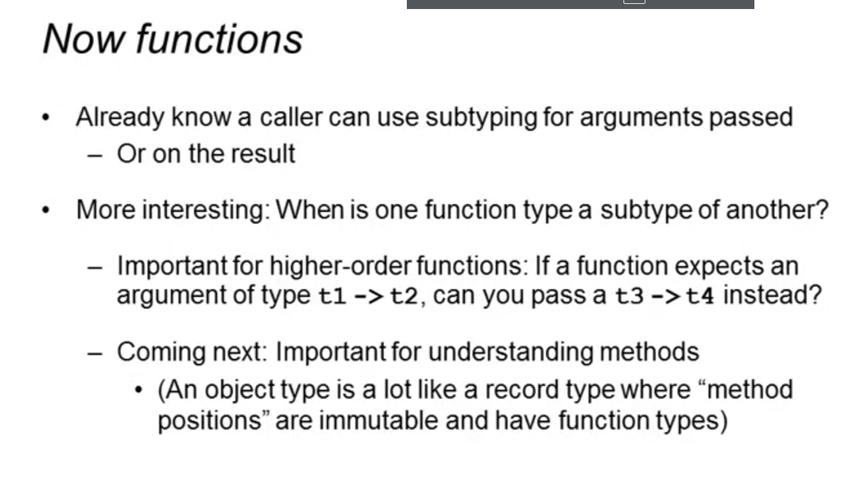

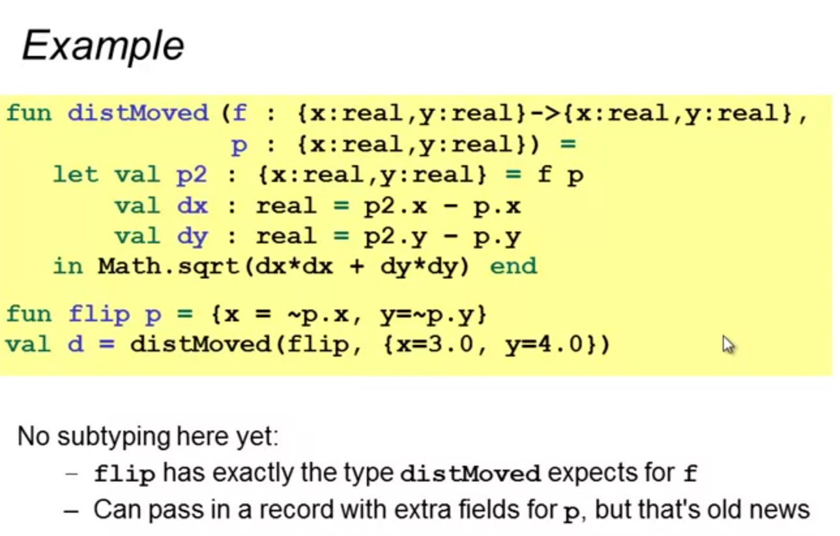

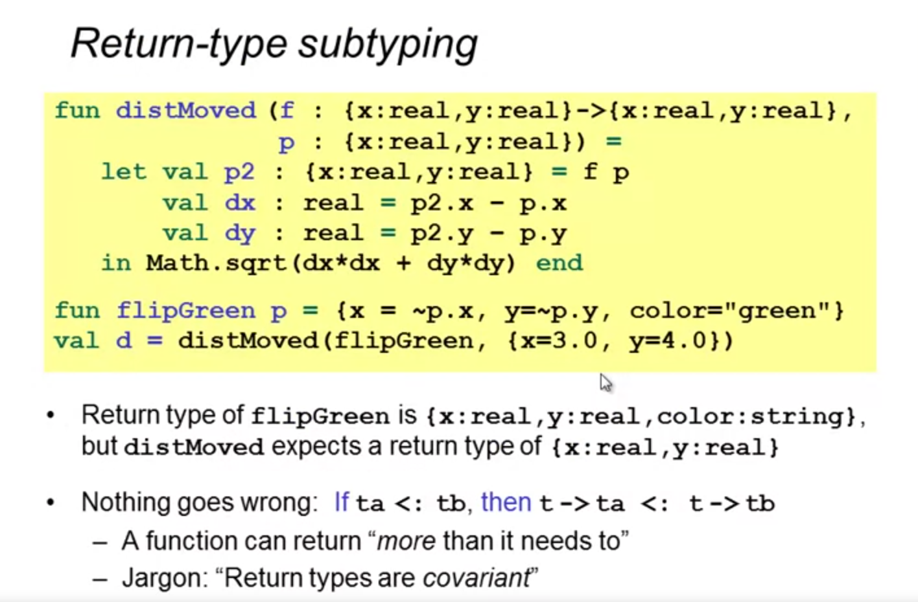

* Subtyping on return-type is sound as long as:
  + It returns “more than” it need to

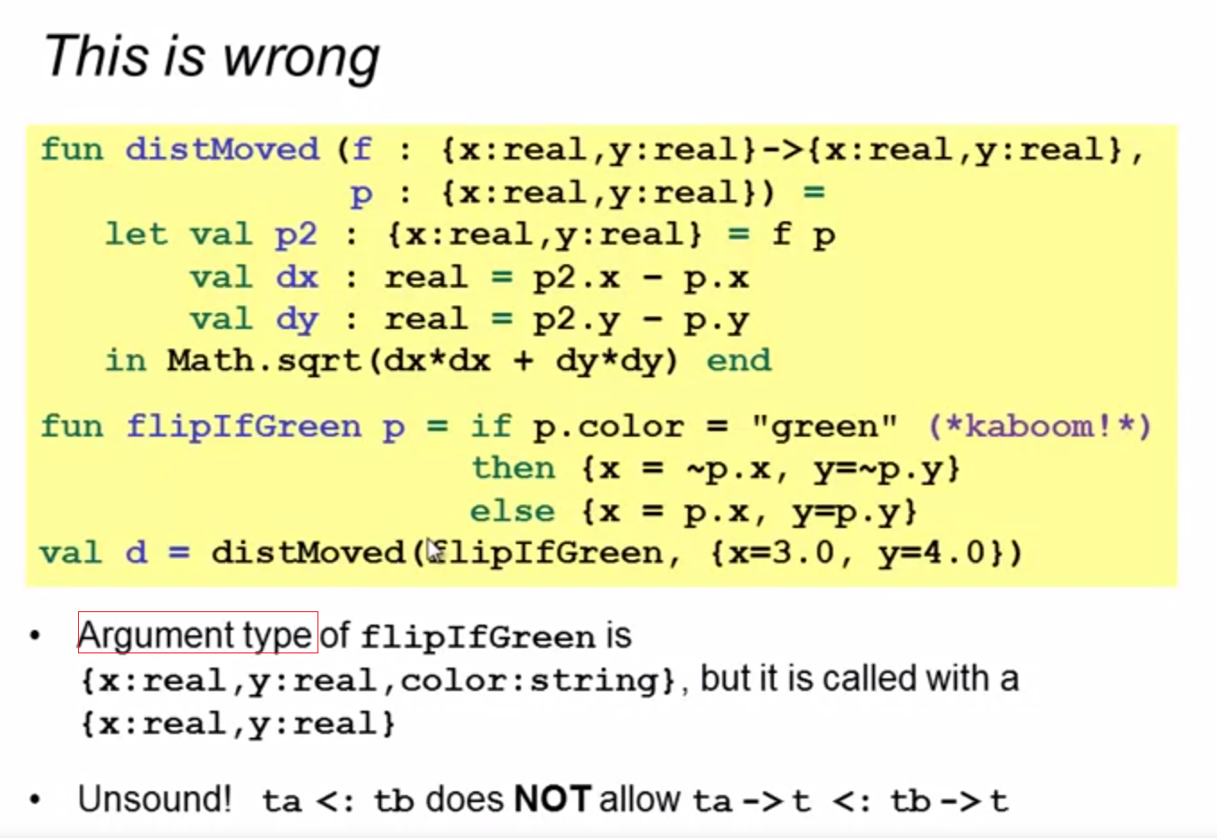

* argument subtyping is not allowed to type checked

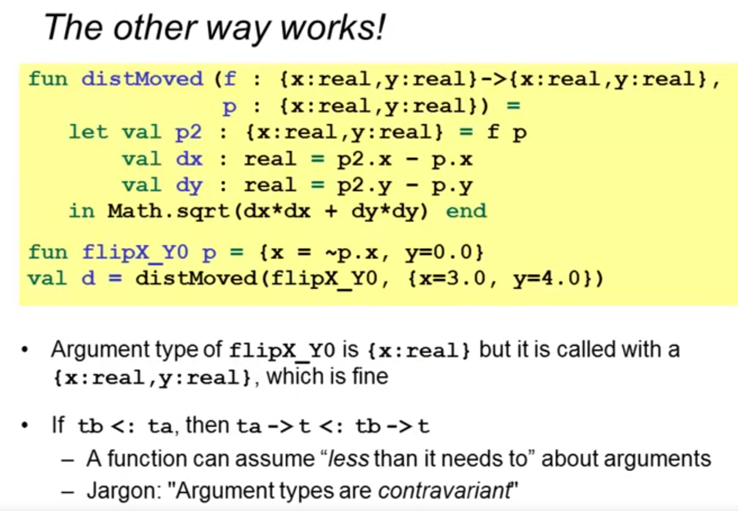

unless:

* It accepts “less than it needs to”

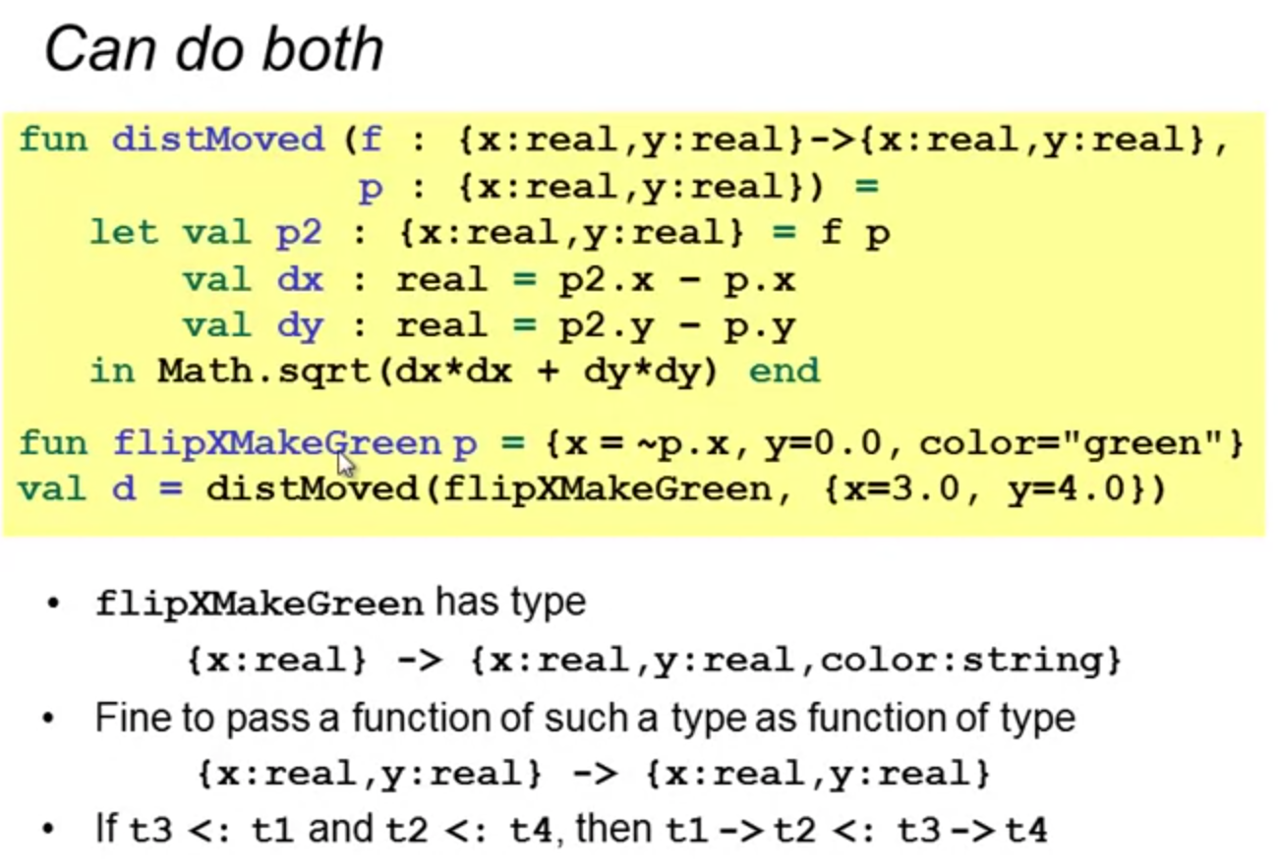

* Return type: more than it needs to
* Argument type: less than it needs to

